**FPT ACADEMY INTERNATIONAL**



## FPT – APTECH COMPUTER EDUCATION



|  |  |  |  |
| --- | --- | --- | --- |
| **Center Name** | | FPT – Aptech – HCM  Address: 590 Cach Mang Thang Tam, District 3, Ho Chi Minh City | |
| **Instructor** |  | Ms. Le Mong Thuy |  |
| **Class** |  | T1.2104.E0 |  |
| **Group** |  | 05 |  |
| **Group members** | | **Name** | **Student ID** |
|  |  | Nguyen Xuan Binh | Student1316191 |
|  |  | Nguyen Phu Thanh Binh | Student1316199 |
|  |  | Trinh Minh Tam | Student1313751 |
| **Duration** | Start date | 14th July 2021 |  |
| End date | 14th August 2021 |  |

**This is to certify that**

**Mr.:**

Nguyen Xuan Binh

Nguyen Phu Thanh Binh

Trinh Minh Tam

**has successfully designed & developed**

eProject: Venus Handicrafts

**Submitted by:**

Nguyen Xuan Binh

**Date of issue:**

**Authorized Signature:**



**TABLE OF CONTENTS**

FPT – APTECH COMPUTER EDUCATION 1

ACKNOWLEGMENT 4

SYNOSIS 4

PROBLEM STATEMENT 4

CUSTOMER'S REQUIREMENTS SPECIFICATIONS (CRS) 5

Business/Project Objective: 5

Input to the system: 5

Output from the system: 5

Expected delivery date: 5

List of deliverables: 5

Hardware/ Software Requirements: 6

For developer 6

For web users 6

SCOPE OF THE WORK (IN BRIEF) 6

Architecture and design of the system 7

Diagram of the website 8

TASK SHEET REVIEW 1 9

SITE MAP 10

MOCK OF THE WEBSITE 11

**1.** **Homepage** 11

**2.** **Products** 12

**3.** **Blog** 13

**4.** **Gallery** 14

**5.** **About us** 15

**6.** **Contact** 16

**7.** **Sign up & Login** 17

TASK SHEET REVIEW 2 18

WEBSITE DESCRIPTION 19

***1.*** **Home Page** 19

***2.*** **Product** 21

***3.*** **Gallery** 22

***4.*** **About us** 22

**c)** **Contact us** 24

**d)** **Login:** 25

**e)** **Blog** 26

JAVASCRIPT DESCRIPTION 27

# ACKNOWLEGMENT

Our team dedicate this project to express our deep gratitude towards the supporters who have helped us to bring up the ideas and guided us to achieve the final product from this eProject.

First of all, we would like to make the most thankful appreciation to our beloved assistant that is our instructor as well – Ms. Le Mong Thuy, who always support our opinions and our beliefs. Of course there are situations where that’s the difficult stage - as well as others where a project was left incomplete for logistical or timing reasons. However, she’s always there for us to end up being more successful.

Next, the accomplishment of this project was sometimes struggling with the idea of aiming for anything harder than our knowledge at this time. However, the collaboration among all team members become a confidence boost that comes with attempting. Even though we have gone through many obstacles during making project, eventually we have learned and got what we aimed at by our hard work, our strong commitment, and our motivational standpoint.

Furthermore, we would like to make a grateful expression of gratitude to Aptech’s education systems, we reconsider our goals before even embarking on something new for the eProject to apply what we have learnt into reality and gain more experience which is necessary for our future career.

# SYNOSIS

In this eProject, we must say that this is an effective simulation of real project. The developer team have to design a front-end website that call Venus Handicrafts. In particular, our designed website brings our viewer to the world of an aesthetic blend of different cultures with amazing handcrafts.

To build up the whole website and layouts, we apply HTML, CSS, Javascript, Bootstrap as means of transmission to build up the inevitable parts for the website of Venus Handcraft.

Our design takes the viewer to a pleasant journey anyone who appreciate the beauty of handmade stuffs and their cultures. Whether you’re looking for meaningful crafts with your loved ones or have chance to allow yourself having a wistful affection for the past, returning to the meaningful time with fascinating people. Furthermore, we have made our website for those who wish to learn more and connect a part of a cultural handcrafts. Above all, we take viewer to a journey that get something bigger than their imaginations before getting in and visiting our website.

# PROBLEM STATEMENT

Venus Handicrafts is certified company engaged in manufacturing and exporting of Decorative Handicrafts to global importers, wholesalers and retailers since 1972.

The ever-increasing acceptance of their products on global platform highlights their market presence and goodwill. The company has maintained its market value throughout the world.

To enhance the product value of our customer, in addition to product-related factors such as: Quality products and good prices, diverse designs. The element of promoting product information to customers is an important issue.

To do that, we will design for them a website that guarantees high aesthetics. Viewers will feel the value of the product: Cultural value, artistic value, and especially, viewers will see the combination between sophisticated craft methods and artistic creativity.

From there, the Venus Handicrafts brand will be raised to a higher level. In addition, the website that we create will guarantee the specifications mentioned below

The website is to be developed for the Windows Platform using HTML5, JavaScript and Geolocation. The site should work well in all leading browsers including Chrome, IE, Firefox etc.

# CUSTOMER'S REQUIREMENTS SPECIFICATIONS (CRS)

* Venus Handicrafts

## Business/Project Objective:

Venus Handicrafts is certified company engaged in manufacturing and exporting of Decorative Handicrafts to global importers, wholesalers and retailers since 1972.

To enhance their value, we want to change their website interface they are using.

We will create a website for them with the required specifications mentioned below.

## Input to the system:

* Search.
* Information of registered members on website.

## Output from the system:

* A menu that will categorize all the functions of the site.
* Displays popular and newest products.
* Displays results of products that users are searching.
* Displays handicraft photos.
* Description of Venus products, establishment, a summary of business, statement, vision, and customer value.
* Displays the company name, phone number, wire number, email, address, fanpages, and GEO CODE location on Google Map.
* Displays information of registered members collected from registration form.
* Displays login interface to collect inputs from customer's accounts.

## Expected delivery date:

* Expected delivery date: 14th August 2021

## List of deliverables:

* Document Word.
* User Guide.
* Source code.

## Hardware/ Software Requirements:

### For developer

#### Hardware

* + Intel Pentium 4 processor or higher.
  + 1 Gigabytes of RAM or higher.

#### Software

* + Windows 7 OS or higher.
  + Adobe Dreamweaver.
  + Web browsers such as IE, Chrome or Firefox are supporting HTML5, CSS3 and Javascript.

### For web users

#### Hardware

* + Intel Pentium 4 processor or higher.
  + 512 Megabytes of RAM or higher.

#### Software

* + Windows XP OS or higher.
  + Web browsers such as IE, Chrome or Firefox are supporting HTML5, CSS3 and Javascript.

## SCOPE OF THE WORK (IN BRIEF)

After a long and detailed discussion, our group has decided to create a website contain the following webpages:

1. **Homepage**: Displays and lists couples of information about popular and new products of Venus Handicrafts.
2. **Products:** Displays the list, the categories, and the information about every specific product of Venus Handicrafts.
3. **Blog:** Displays news, global industry trends, and handicraft markets.
4. **Gallery** : Showing a wonderful collection of images about Venus Handicrafts as well as amazing pictures of fascinating handcrafts.
5. **About us*:*** Displays a summary about history, mission setting out by Venus to their customers understanding their business, and their vision to see how far that Venus can go in global handicraft market. Also, publishing some pictures about the company Venus Handicrafts to reveal their transparent works.
6. **Contact:** Displays information of contact such as wire number, social network, or address. Sharing location via a map on Google of Venus Handicrafts
7. **Sign-up & Login:**

* Displays a form that collects some information from customers
* Displays a user interface that allows customers or users to login for more customer dedications from Venus

# Architecture and design of the system

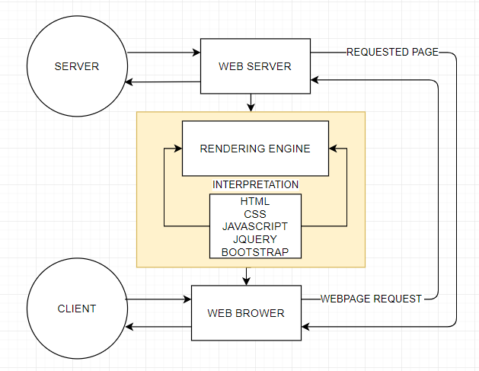

# Diagram of the website

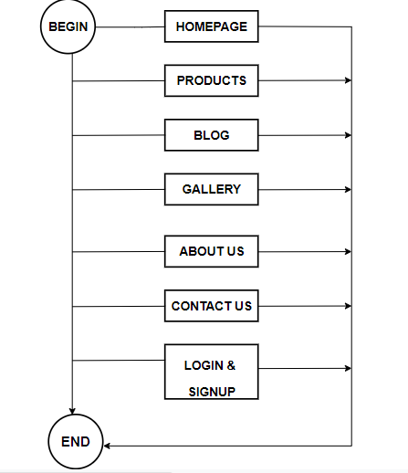



# TASK SHEET REVIEW 1

|  |  |  |  |  |  |  |  |
| --- | --- | --- | --- | --- | --- | --- | --- |
| **Project Ref. No.:**  **eP/Advertisement Portal Management**  **System/01** | | **Project Title:** | **Activity Plan Prepared By:** | **Date of Preparation of Activity Plan:** | | | |
| **Sr.**  **No.** | **Task** | **Actual**  **Start Date** | **Actual Days** | **Team**  **Mate Names** | **Status** |
| 1 | Problem Statement | Venus Handicrafts | Bình | 15-July-21 | 1 | Thanh Bình | Completed |
| 2 | Analysis of Venus Handicrafts requirements about the website | 15-July-21 | 1 | Xuan Binh | Completed |
| 3 | The scope of the work (in brief) | 15-July-21 | 1 | Minh Tam | Completed |
| 4 | Architecture and design of the system | 15-July-21 | 1 | Xuan Binh | Completed |
| 5 | Diagram of the website | 15-July-21 | 1 | Minh Tam | Completed |
| 6 | Task Sheet | 15-July-21 | 1 | Thanh Bình | Completed |

|  |  |
| --- | --- |
| **Date:** | |
| Signature of Instructor:  **Ms. Le Mong Thuy** | Signature of Team Leader:    **Nguyen Xuan Binh** |

# SITE MAP

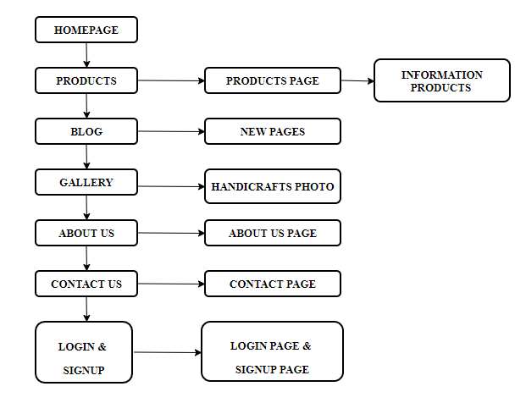

# MOCK OF THE WEBSITE

1. **Homepage**

**LIVESHOW**

**NEW PRODUCTS**

**POPULAR PRODUCTS**

**HEADER**

**(NAVIGATION BAR – LOGIN – SIGN UP)**

**FOOTER**

1. **Products**

**LIVESHOW**

**HEADER**

**(NAVIGATION BAR – LOGIN – SIGN UP)**

**PRODUCTS**

**MENU**

**FOOTER**

1. **Blog**

**FOOTER**

**HEADER**

**(NAVIGATION BAR – LOGIN – SIGN UP)**

**Contents**

**BANNER**

1. **Gallery**

**HEADER**

**(NAVIGATION BAR – LOGIN – SIGN UP)**

**FOOTER**

**PRODUCTS**

**LIVESHOW**

1. **About us**

**FOOTER**

**HEADER**

**(NAVIGATION BAR – LOGIN – SIGN UP)**

**BANNER**

**ABOUT US**

1. **Contact**

**HEADER**

**(NAVIGATION BAR – LOGIN – SIGN UP)**

**BANNER**

**MAP**

**CONTACT US**

**FOOTER**

1. **Sign up & Login**

**HEADER**

**(NAVIGATION BAR – LOGIN – SIGN UP)**

**SIGN-UP FORM**

**LOGIN FORM**

**FOOTER**

# TASK SHEET REVIEW 2

|  |  |  |  |  |  |  |  |
| --- | --- | --- | --- | --- | --- | --- | --- |
| **Project Ref. No.:**  **eP/Advertisement**  **Portal Management System/01** | | **Project Title:** | **Activity Plan Prepared By:** | **Date of Preparation of Activity Plan:** | | | |
| **Sr.**  **No.** | **Task** | **Actual Start Date** | **Actual Days** | **Team Mate Names** | **Status** |
| 1 | Site map | Venus Handicrafts | Binh | 18-July-21 | 1 | Thanh Binh | Completed |
| 2 | Mock of the website | 18-July-21 | 2 | Minh Tam | Completed |
| 3 | Task sheet | 18-July-21 | 2 | Xuan Binh | Completed |

|  |  |
| --- | --- |
| **Date:** | |
| Signature of Instructor:  **Ms. Le Mong Thuy** | Signature of Team Leader:  **Nguyen Xuan Binh** |

# WEBSITE DESCRIPTION

1. **Home Page**
2. Description:

Home page displays following information:

* Working hours, hotline number, a live show of banners, and some features
* Showing some New products.
* Showing some Hot Products.
* Footer includes contact, products are, news, social networks icons, and copyright.

1. Screen shot:

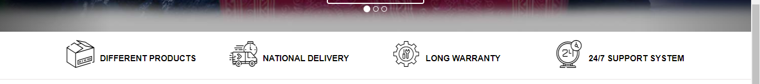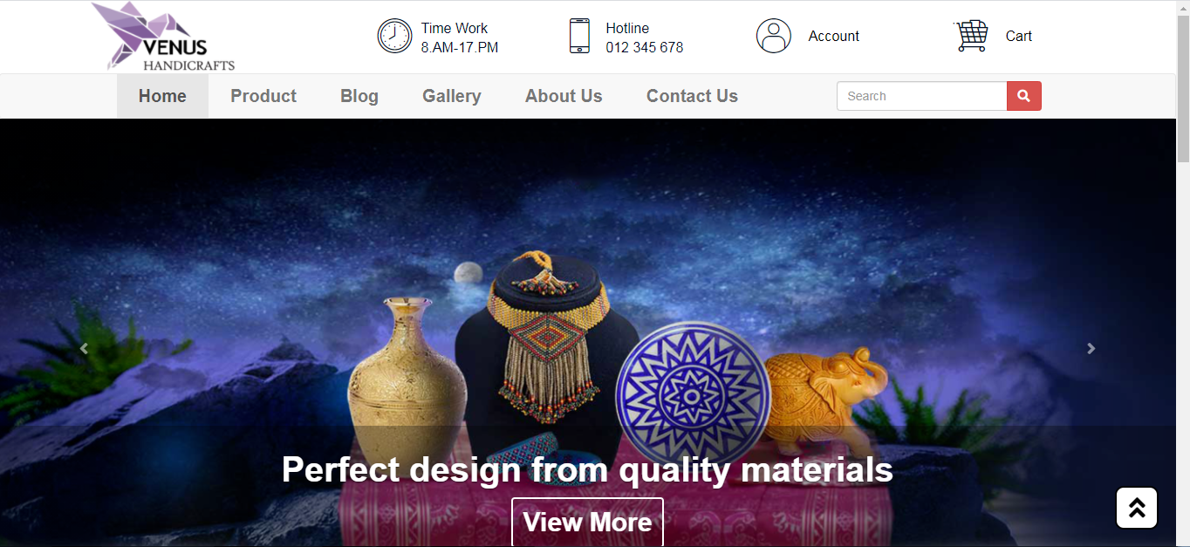

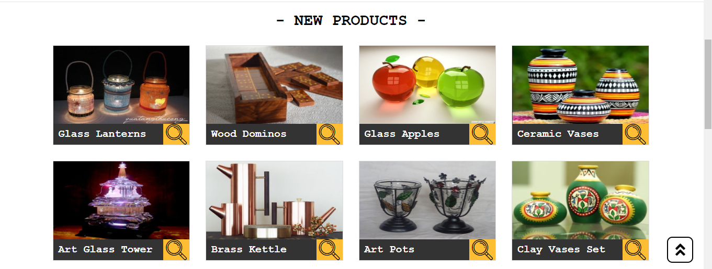

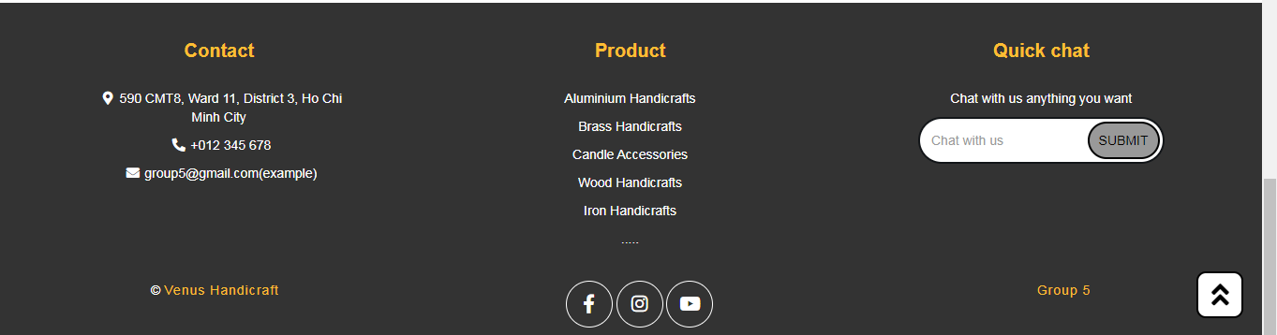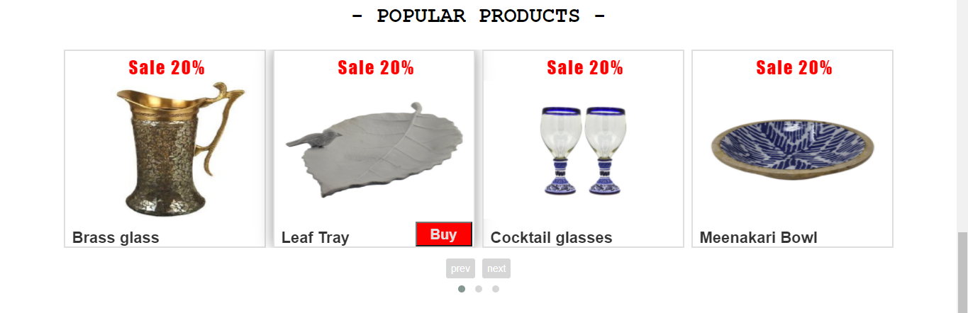

1. **Product**
2. Description:

Product page displays the following information:

* Header, Footer, and Navigation are working the same as other pages.
* Show all products for sale at Venus Handicraft.
* When clicking on a specific product will display detailed information of that item (Product code, Product name and price of the product).
* Use menu filters to easily find products based on items.

1. Screen shot:

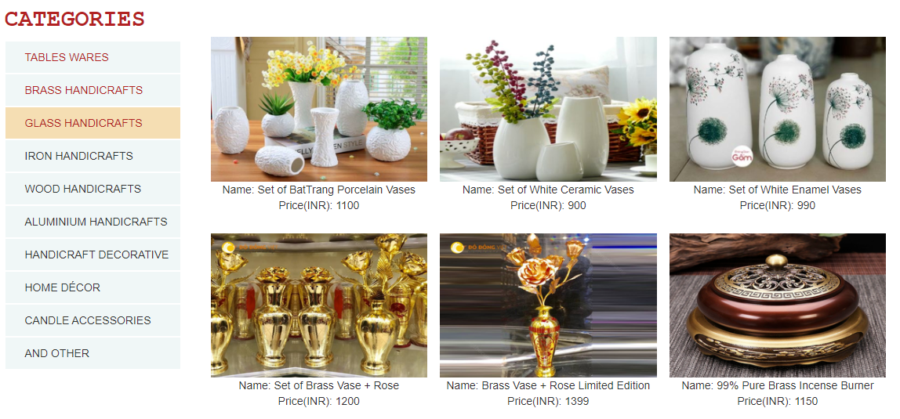

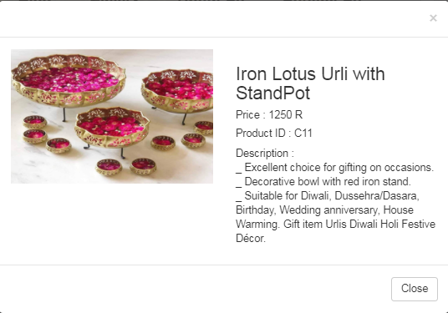

1. **Gallery**
2. Description:

Product page displays the following information:

* The Header, Footer, and Activity controls are the same as other pages.
* Pictures of products being sold at Venus Handicraft.

1. Screenshot:

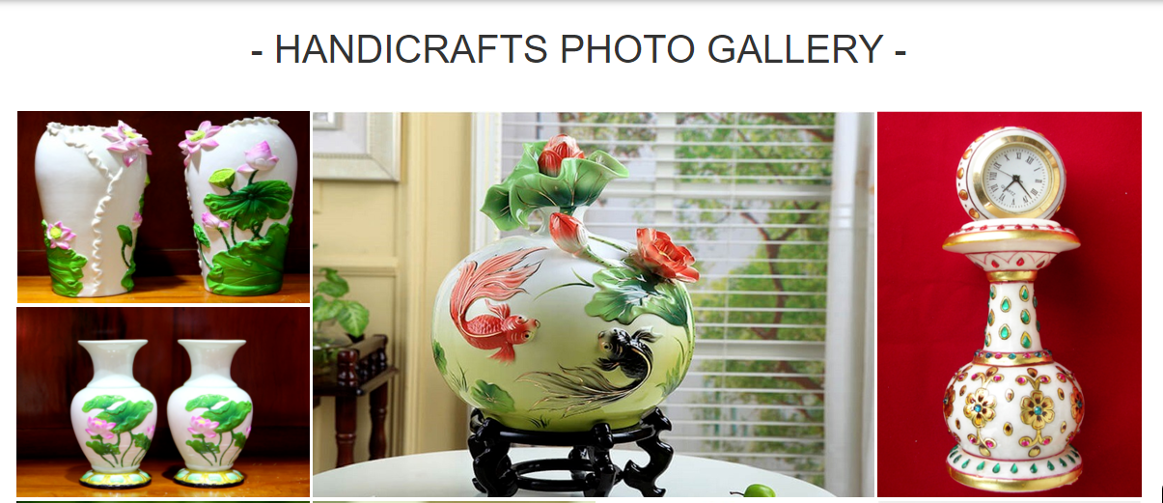

1. **About us**
2. Description:

About uspage displays the following information:

* Header, Footer, and Navigation are working the same as other pages. This page displays more information about features as well as our services, a brief information about the history of Venus Handicraft and some brief information about the quality and characteristics of products from Venus Handicraft.

1. Screen shot:

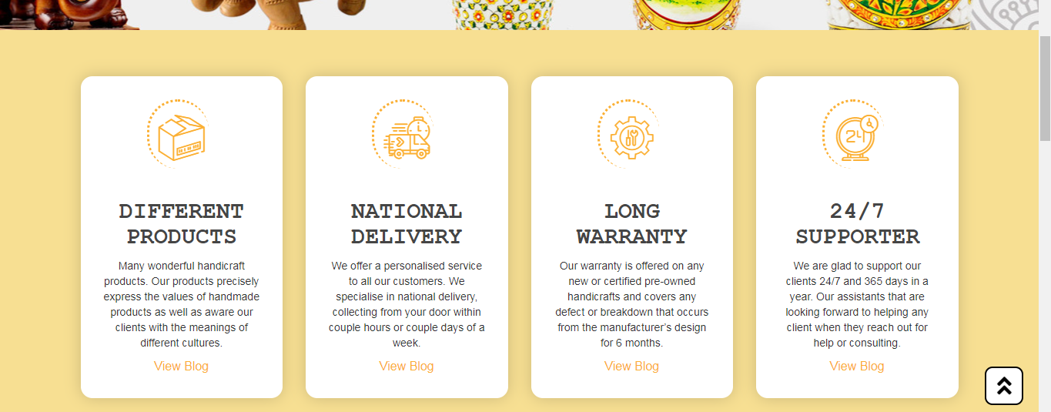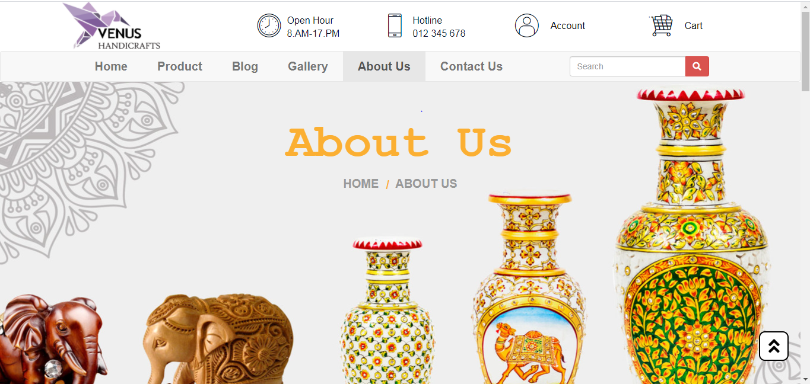

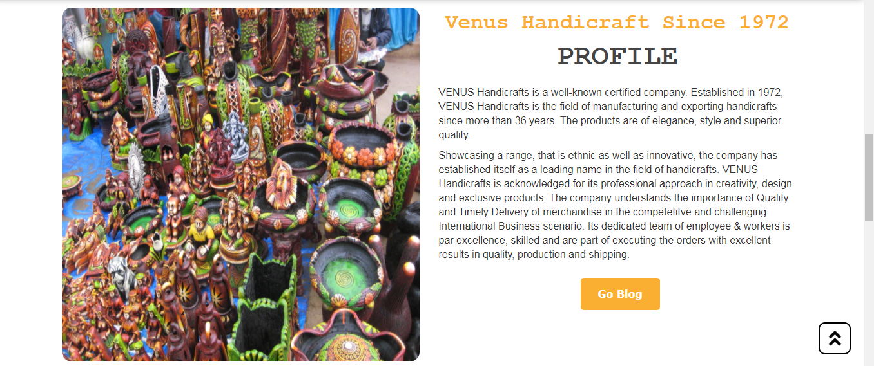

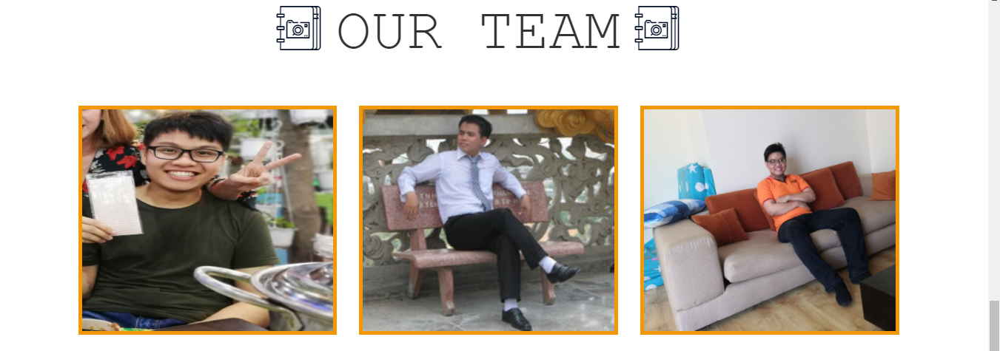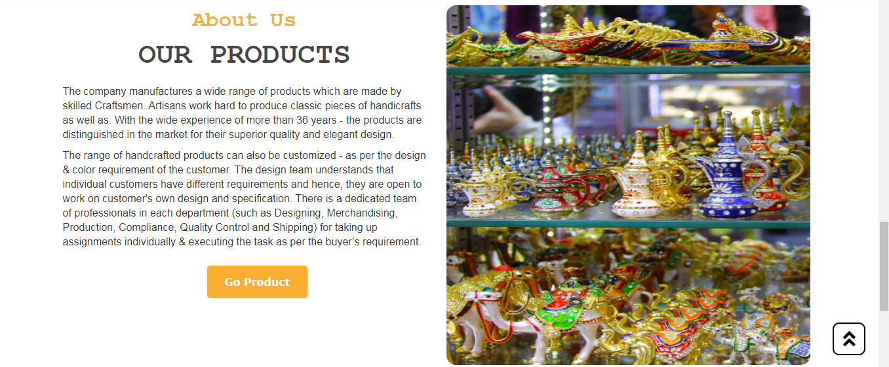

1. **Contact us**
2. Description:

Contact page displays the following information:

* Header, Footer, and Navigation are working the same as other pages. This page displays contact information: including Venus address, hotline number, contact email, social networks, contact form to leave a message to Venus customer service and a map of google to identify Venus location for customers.

1. Screen shot:

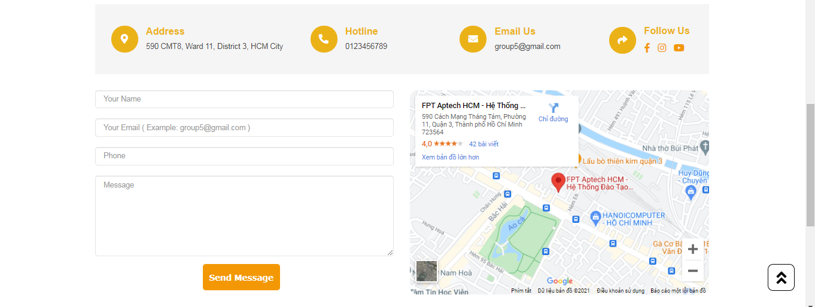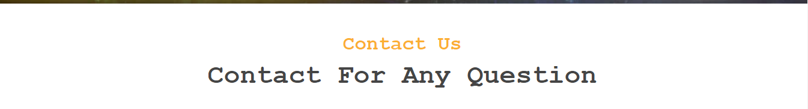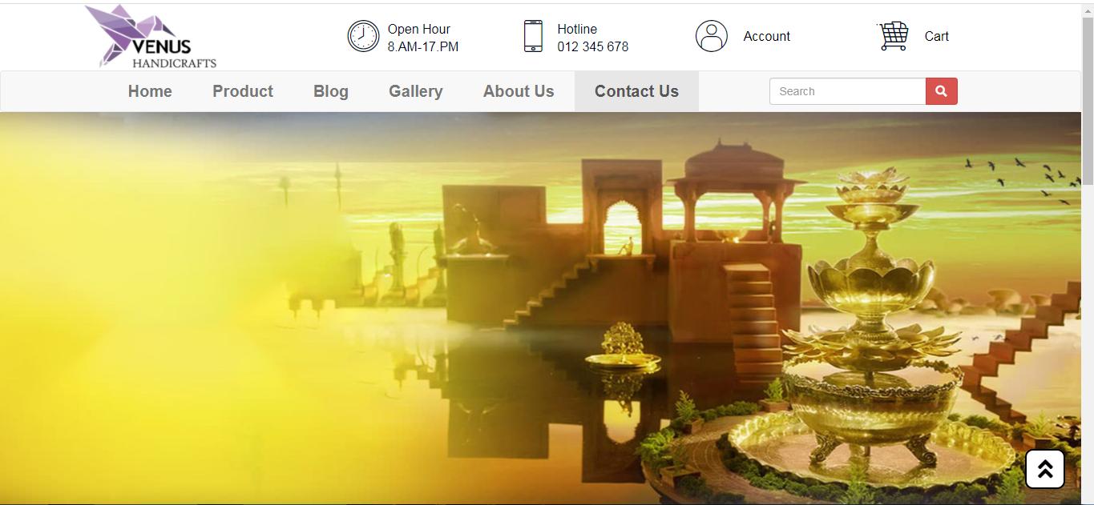

1. **Login:**

**Description:**

* Login page has navigation working the same as homepage. Also, showing the menu contents, working hours, hotline number, and features. Full background of a colorful image to attract clients. Specifically, including a login interface at default in front of the background. If viewers already have accounts, they can try to login but the information form is required exact email format for the Email. The password can be visible or invisible according to viewer’s options. Otherwise, viewers can switch to the Sign up and input information for registration to become memberships with Venus Handicrafts. Footer works the same as others page.

**Screenshot:**

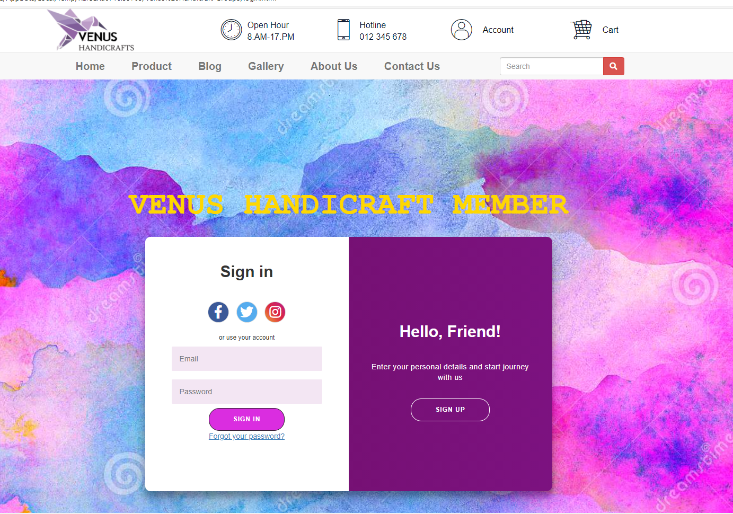

1. **Blog**

**Description:**

* Blog page also hasnavigation working the same as homepage and others page. An attractive banner for stimulating the discovers from the viewers. Separating blog to three different pages and each page has nine newest publications. There are four specific categories to identify different handicrafts social posts from many cultures (ASIAN, EUROPE, AFRICA, and AMERICA). Viewers can easily identify by separated categories and choose the interesting posts for raising aware of handicraft information. Viewers can switch another page between three pages to discover more social posts.

**Screenshot:**

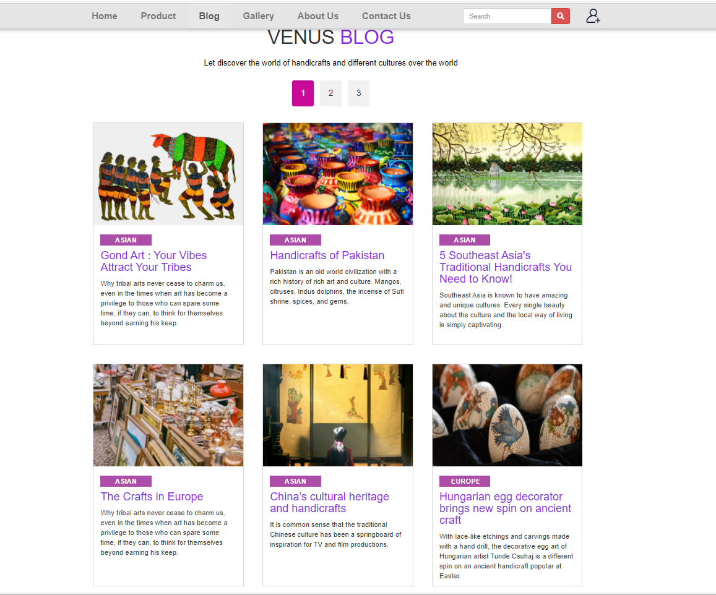

# JAVASCRIPT DESCRIPTION

This chapter will provide information about JavaScript function integrated in the website.

1. **Sticky navbar function**
2. Description

* This script is used for stick navigation bar on top when scrolling in all pages . It is implemented with the support of the Jquery library.

1. Screenshot

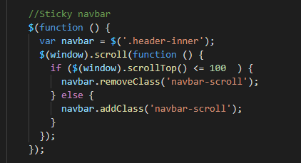

1. **Scroll to top button**
2. Description

* This script is used for making function for a button scroll back to Top when click that button . It is implemented with the support of the Jquery library.

1. 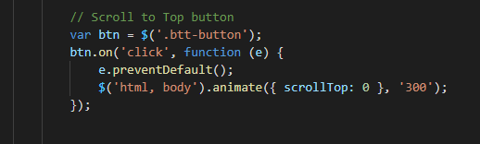Screenshot
2. **Change Left and Right button**
3. Description

* This script is used for creating the effect of running to the left and right of the sign in and sign up frame.

1. 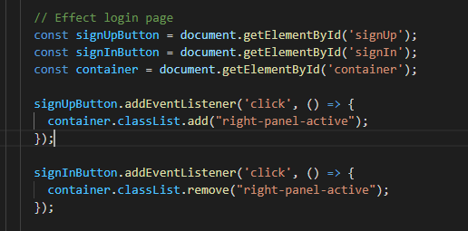Screenshot
2. **Popular products slider**
3. Description

* This script is used for popular products slider. It is implemented with the support of the Jquery library and OwlCarousel library.

1. 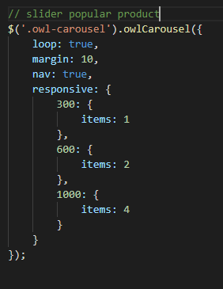Screenshot
2. **Filter blog news**
3. Description

* This script is used for filtering news in blog page to page 1 , page 2, page 3

1. Screenshot

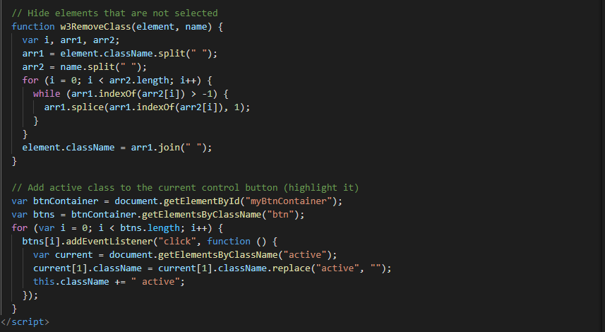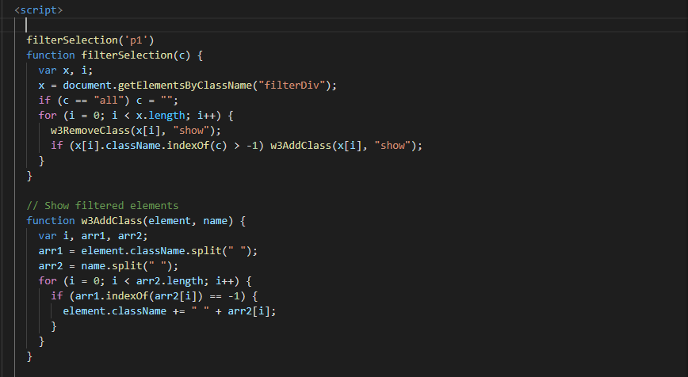

1. **Display and Filter product**
2. Description

* Automatically add data, sort by product type and display available images from an existing data.son file.
* Display product details and description when clicking on a product

1. 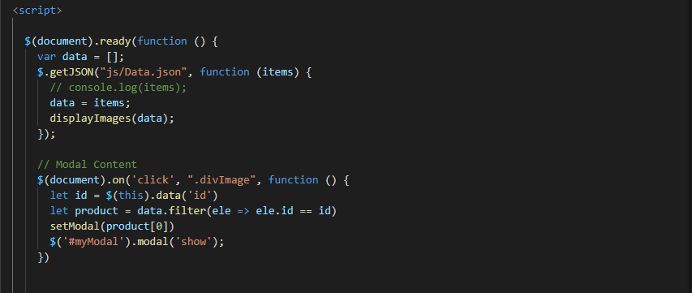Screenshot

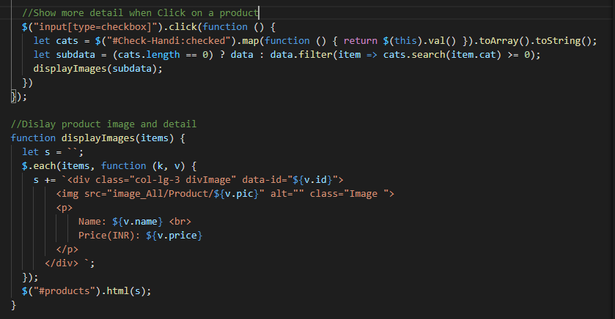

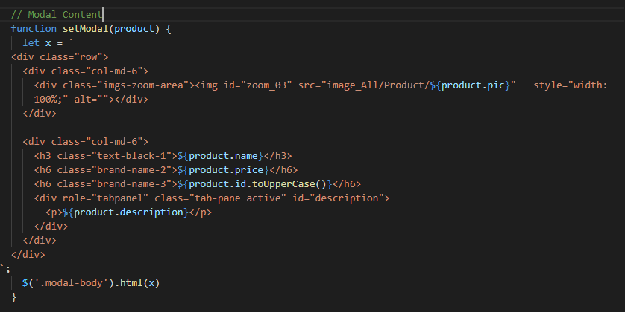

1. **Contact check script**
2. Description

_ Check incomplete input, spelling, thanks

1. Screenshot

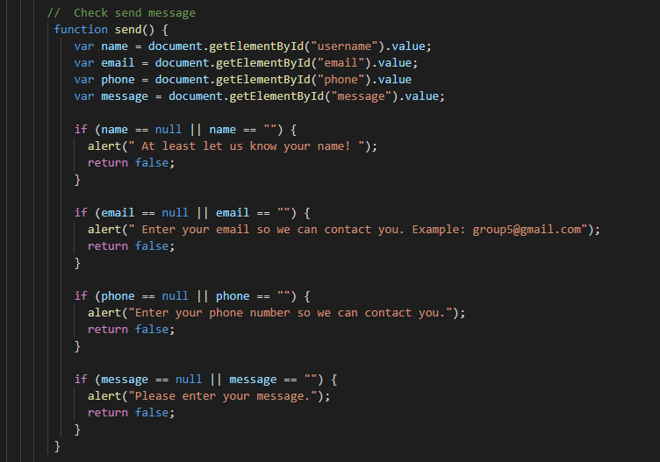

1. **Login/signup check script**
2. Description

_ Check incomplete input, spelling, thanks

1. Screenshot

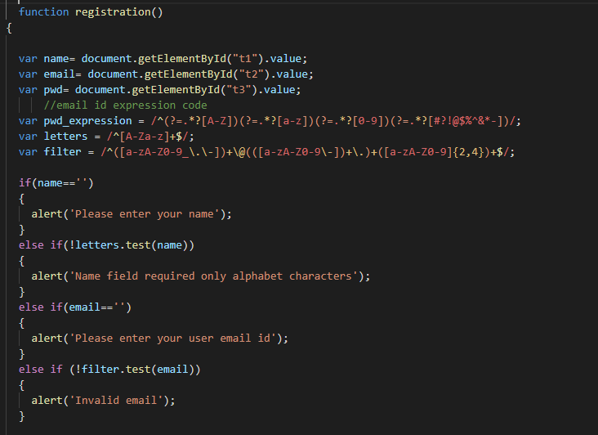

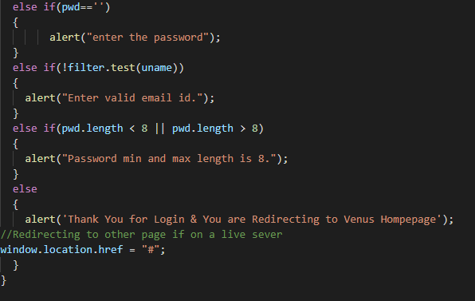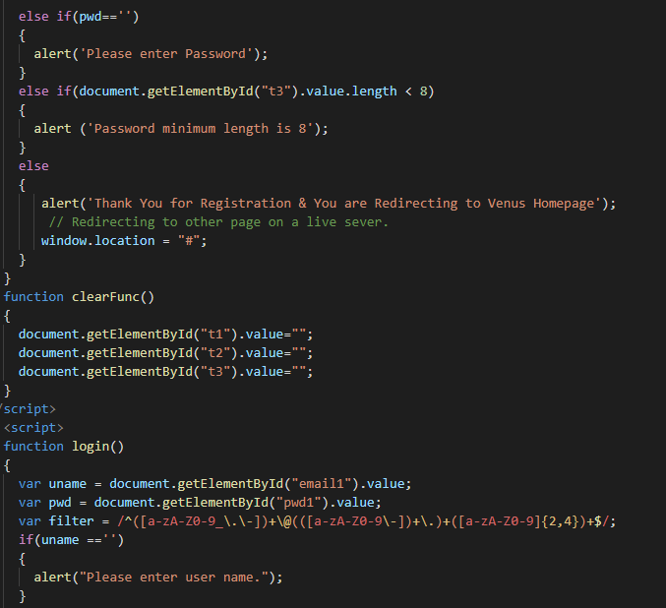

**RESPONSIVE**

The page has responsive feature for small screen device such as smart phone, tablet, etc.

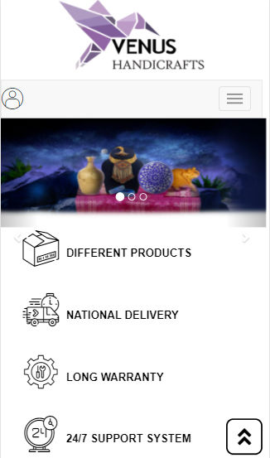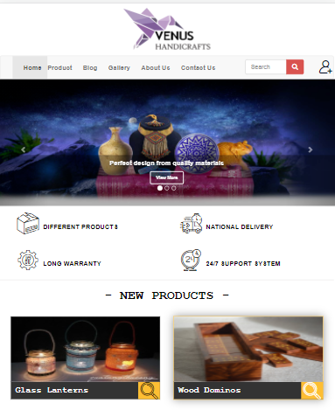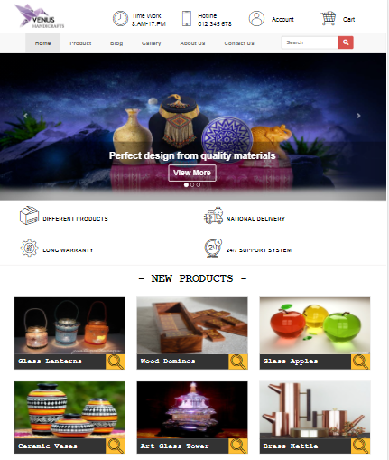

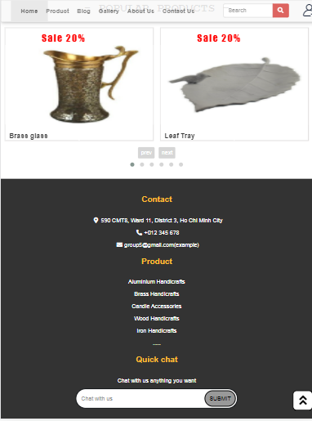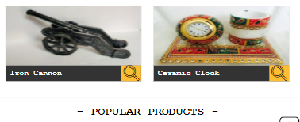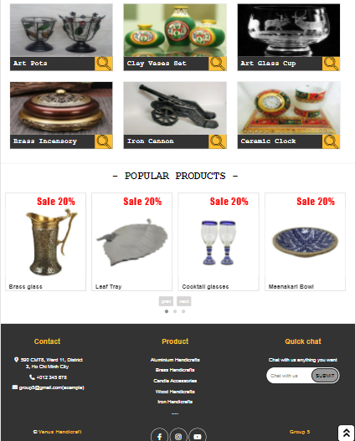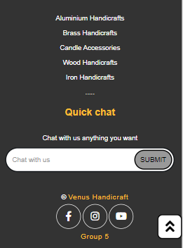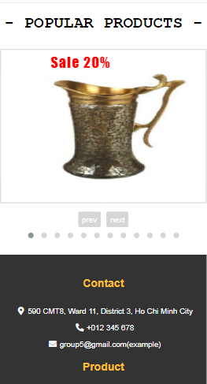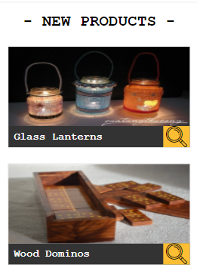

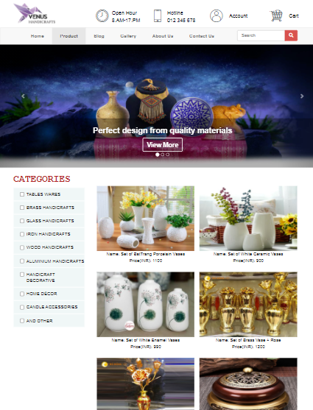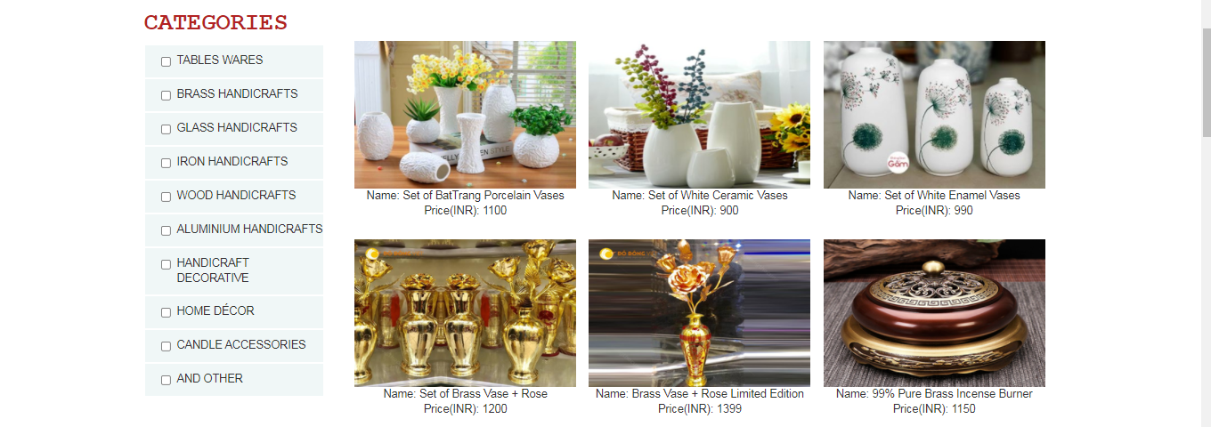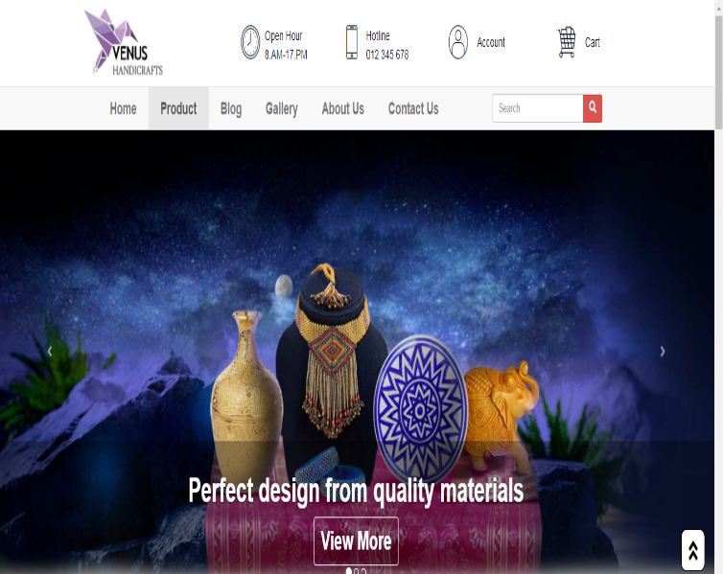

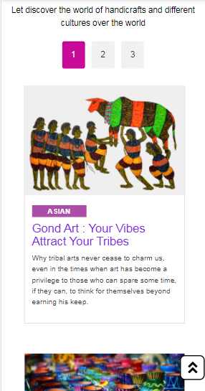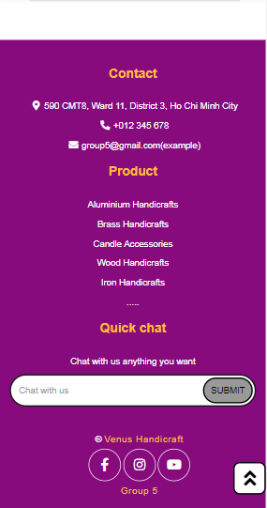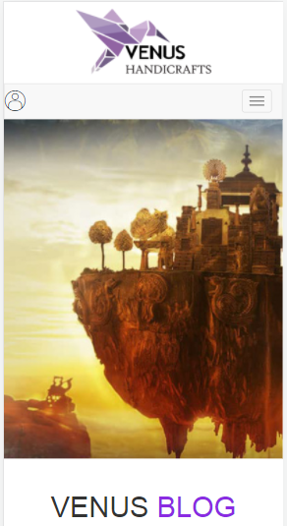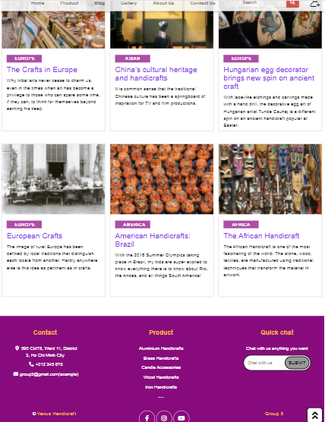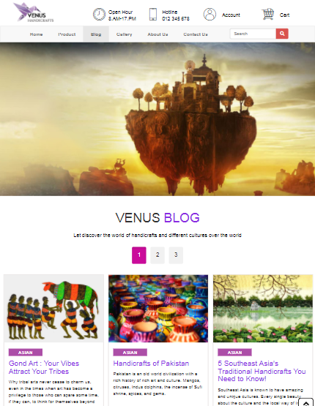

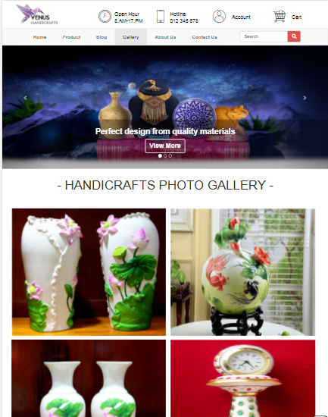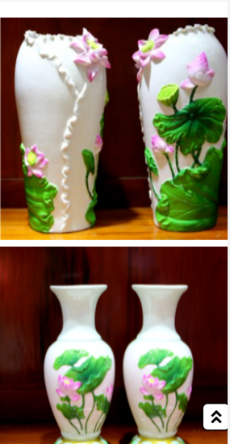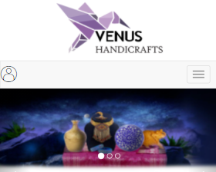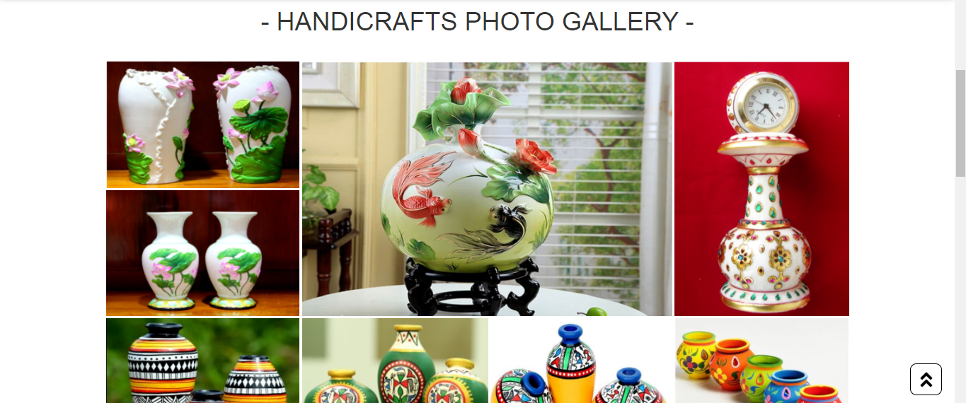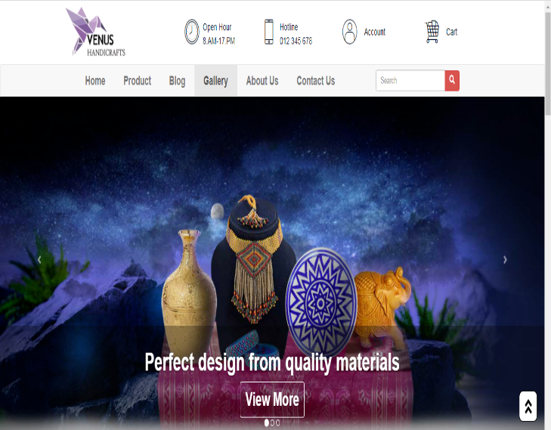

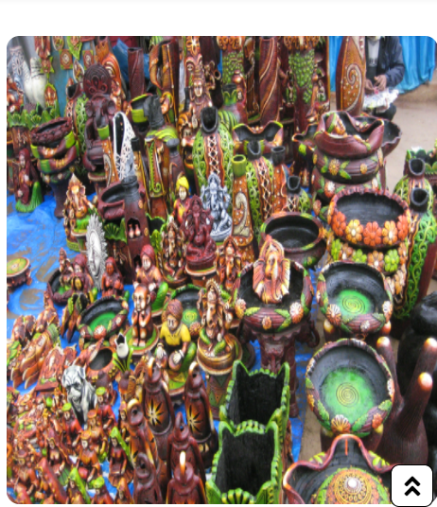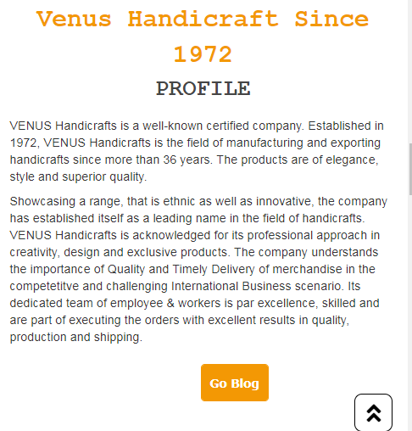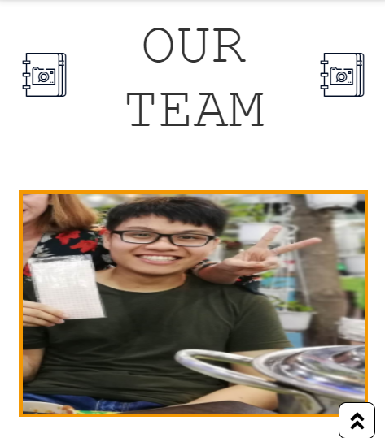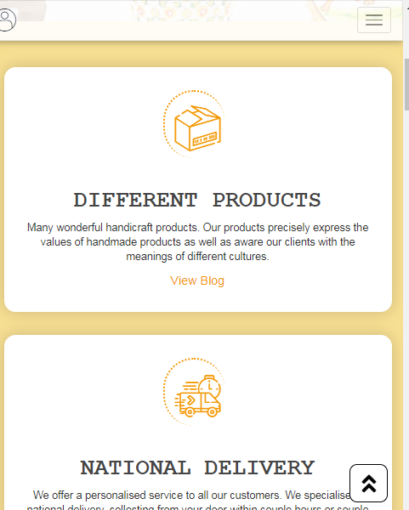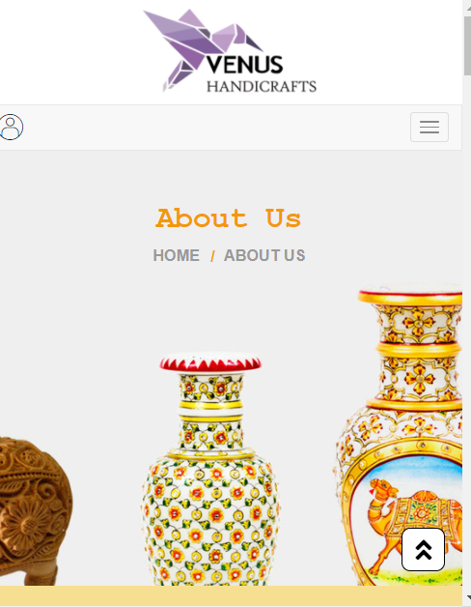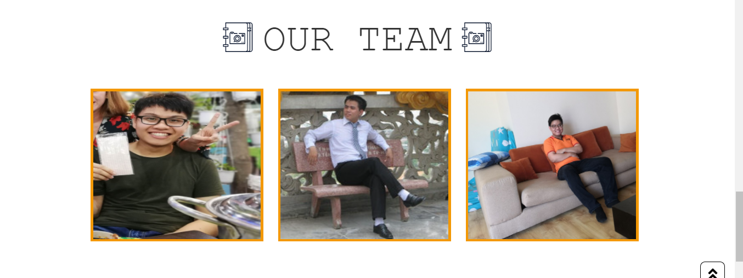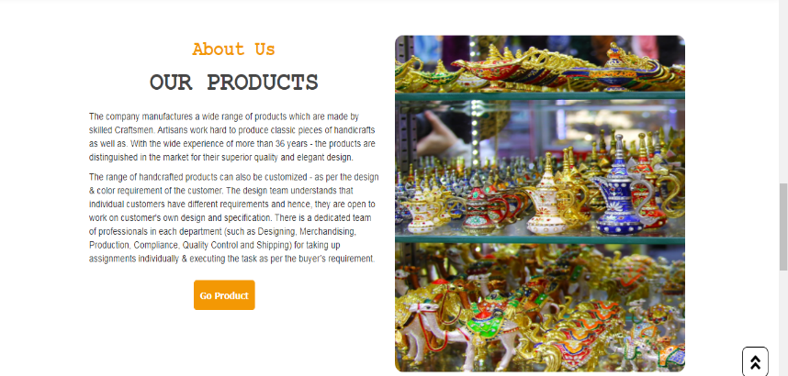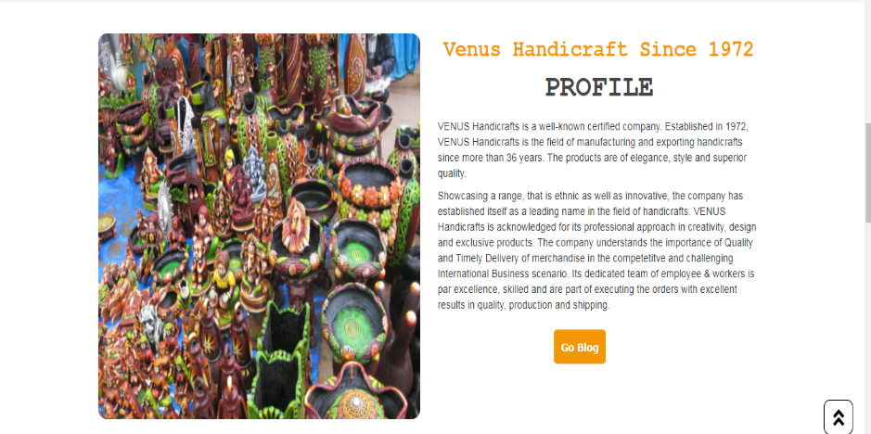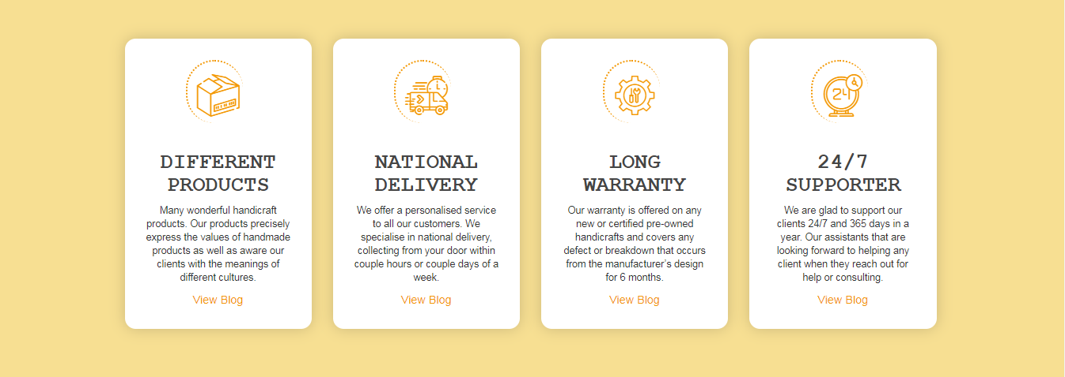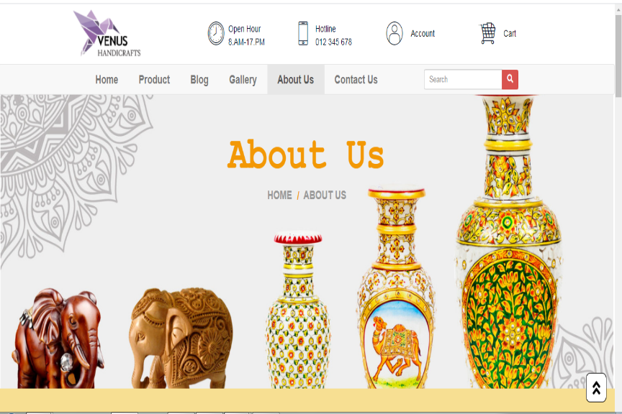

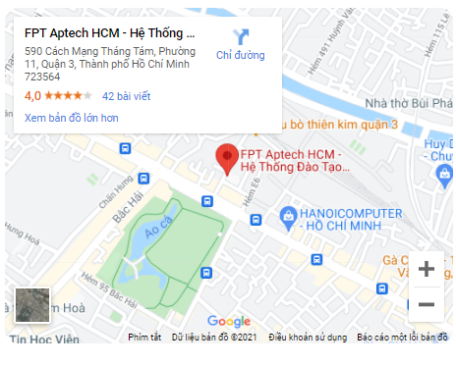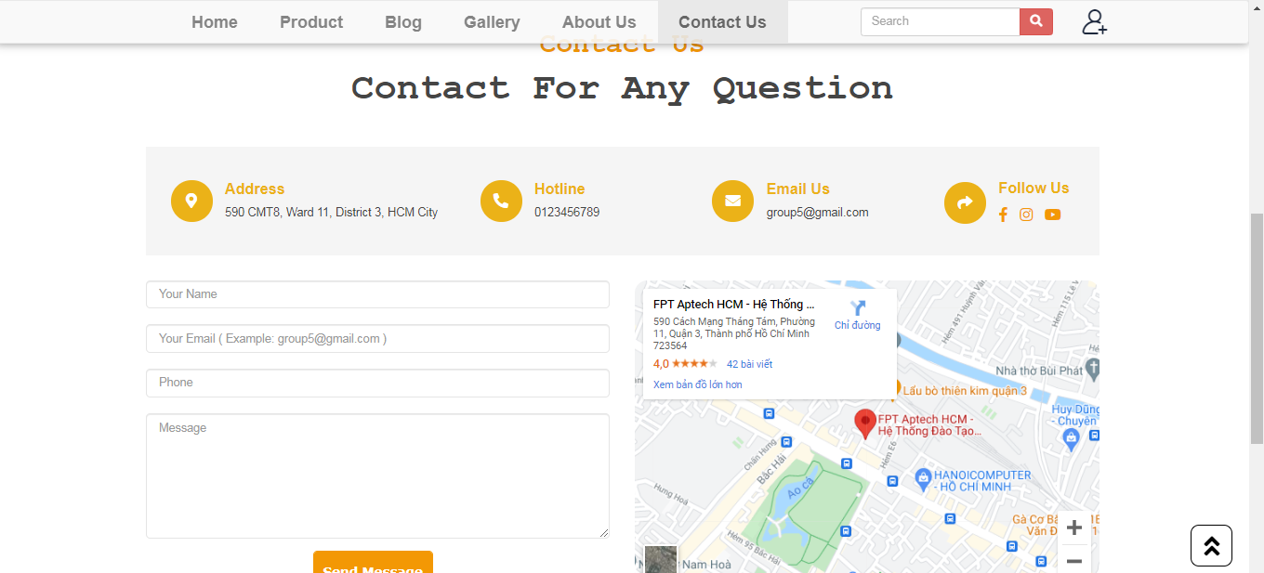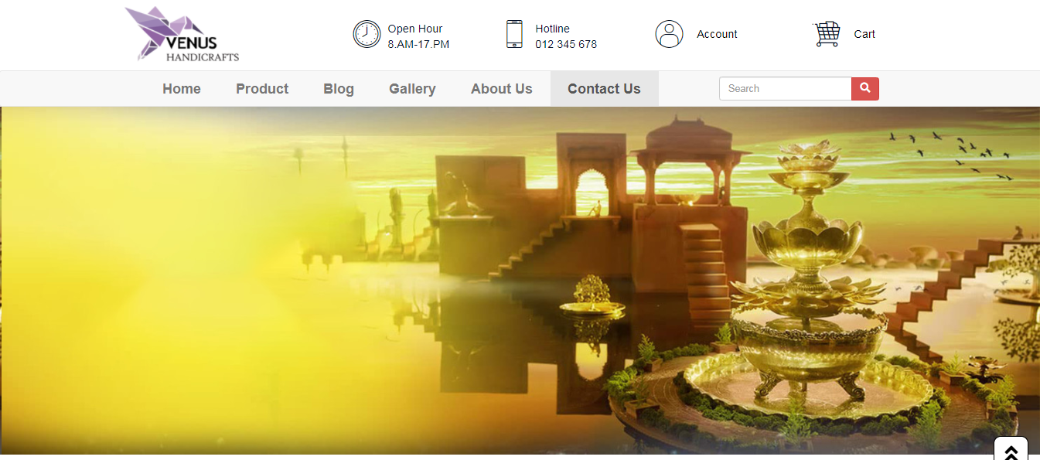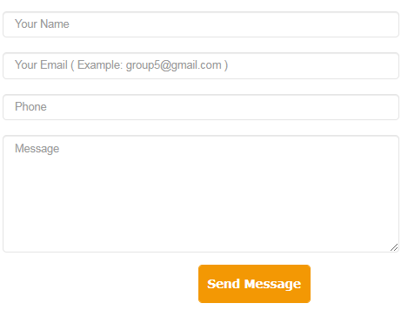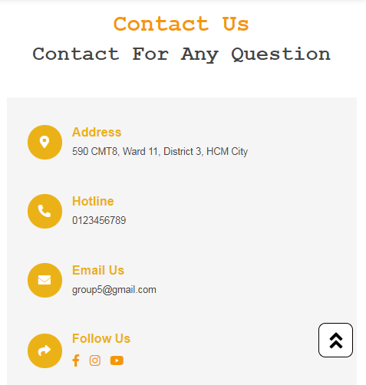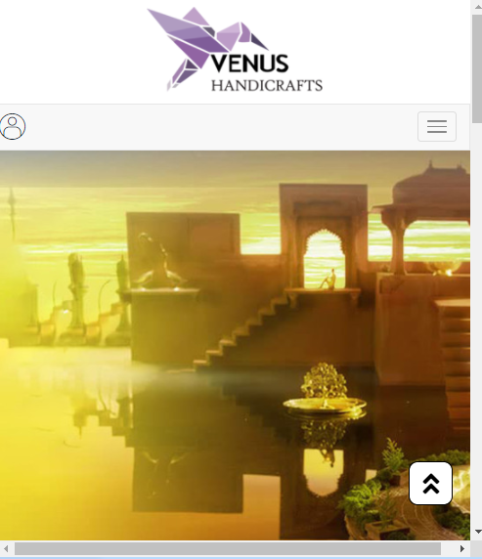

# TASK SHEET REVIEW 3

|  |  |  |  |  |  |  |  |
| --- | --- | --- | --- | --- | --- | --- | --- |
| **Project Ref. No.:**  **eP/Advertisement**  **Portal Management System/01** | | **Project Title:** | **Activity Plan Prepared By:** | **Date of Preparation of Activity Plan:** | | | |
| **Sr.**  **No.** | **Task** | **Actual Start Date** | **Actual Days** | **Team Mate Names** | **Status** |
| 1 | Home page |  |  | 22-July-21 | 4 | Minh Tam | Completed |
| 2 | Product |  |  | 22-July-21 | 4 | Xuan Binh | Completed |
| 3 | Blog | Venus Handicrafts |  | 22-July-21 | 4 | Thanh Binh | Completed |
| 4 | Gallery |  | Xuan Binh | 26-July-21 | 3 | Xuan Binh | Completed |
| 5 | About |  |  | 26-July-21 | 3 | Minh Tam | Completed |
| 6 | Contact |  |  | 26-July-21 | 3 | Thanh Binh | Completed |
| 7 | Sign in & Sign up |  |  | 26-July-21 | 3 | Thanh Binh | Completed |
| 8 | Responsive |  |  | 31-July-21 | 3 | Minh Tam | Completed |
| 9 | Javascript |  |  | 31-July-21 | 3 | Xuan Binh | Completed |
| 10 | User Guide |  |  | 31-July-21 | 3 | Thanh Binh | Completed |

|  |  |
| --- | --- |
| **Date:** | |
| Signature of Instructor:  **Ms. Le Mong Thuy** | Signature of Team Leader:  **Nguyen Xuan Binh** |